Deployment of Amazon Clone App using Terraform and Jenkins CI/CD

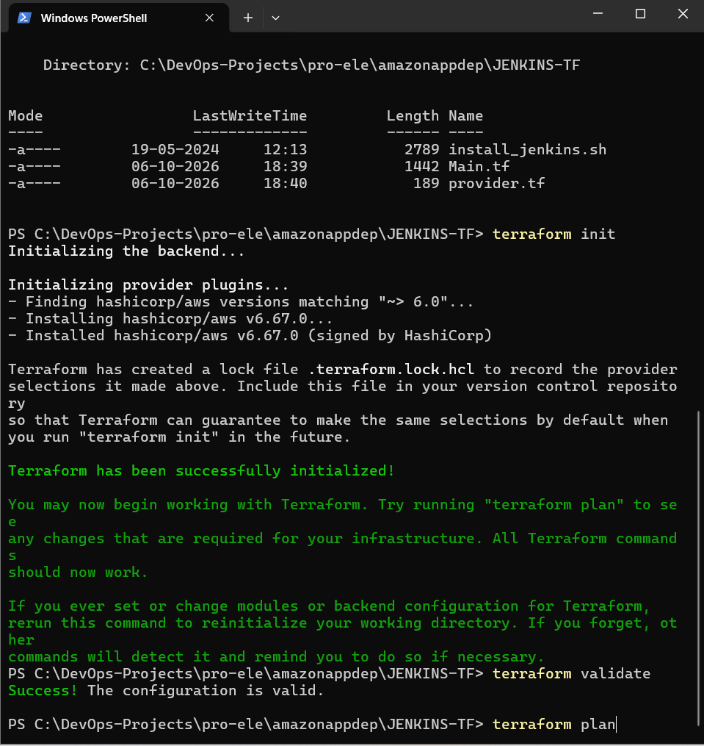

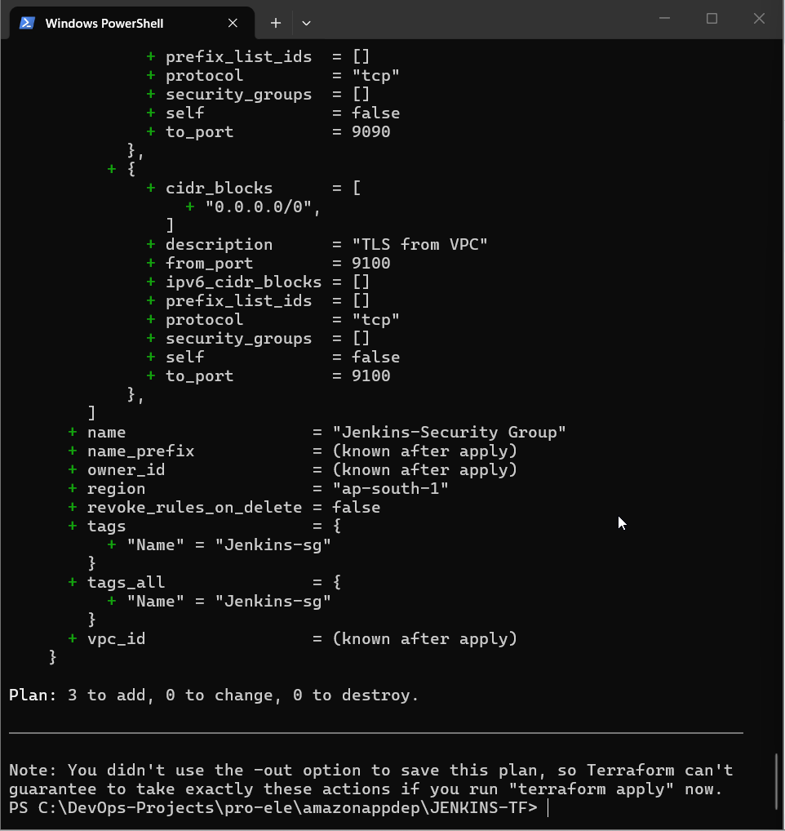

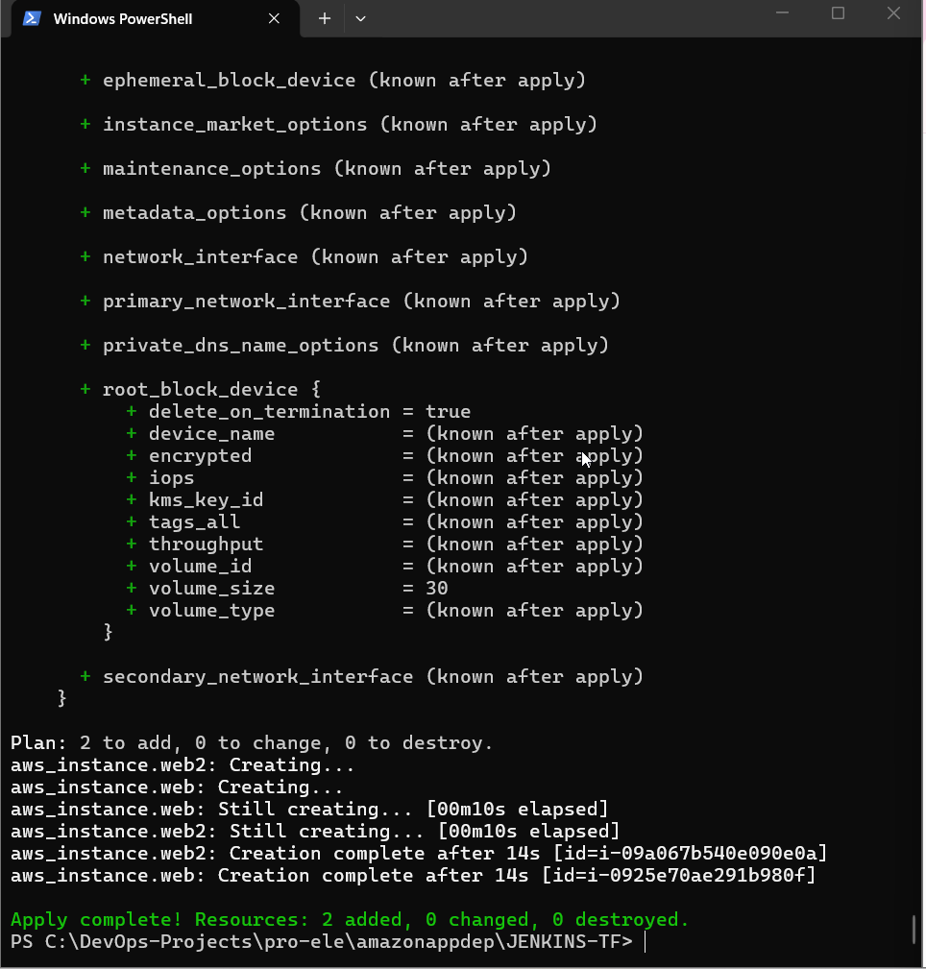

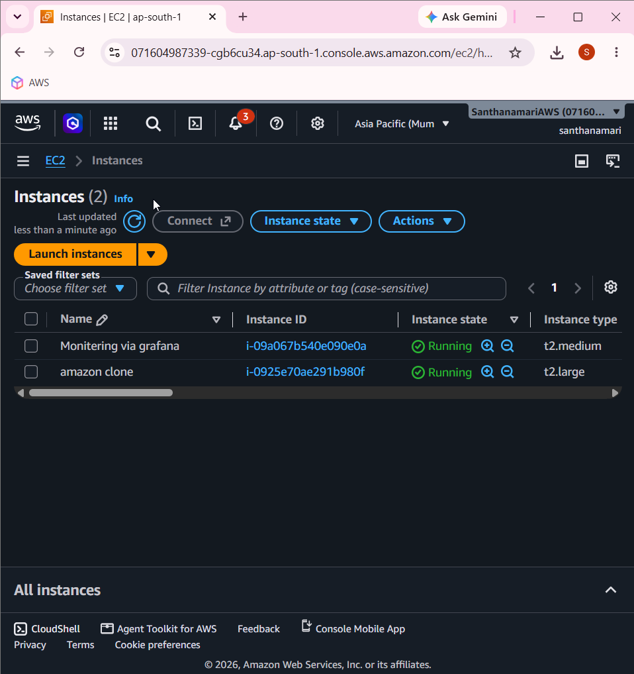

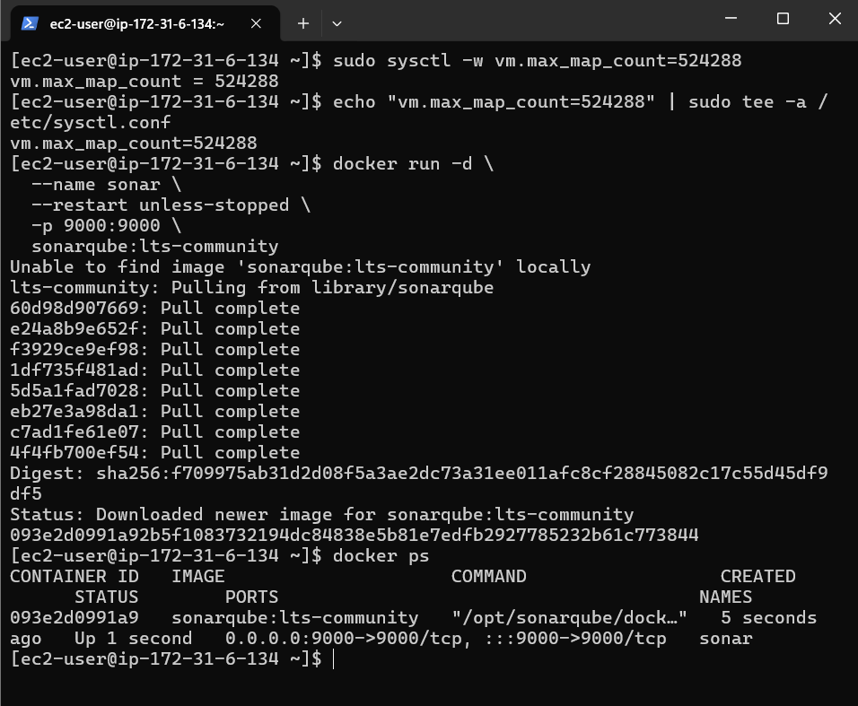

Jenkins

sudo yum install -y java-21-amazon-corretto

sudo wget -O /etc/yum.repos.d/jenkins.repo https://pkg.jenkins.io/redhat-stable/jenkins.repo

sudo rpm --import https://pkg.jenkins.io/redhat-stable/jenkins.io-2023.key

sudo yum install -y jenkins

sudo systemctl daemon-reload

sudo systemctl enable jenkins

sudo systemctl start Jenkins

sudo systemctl status jenkins

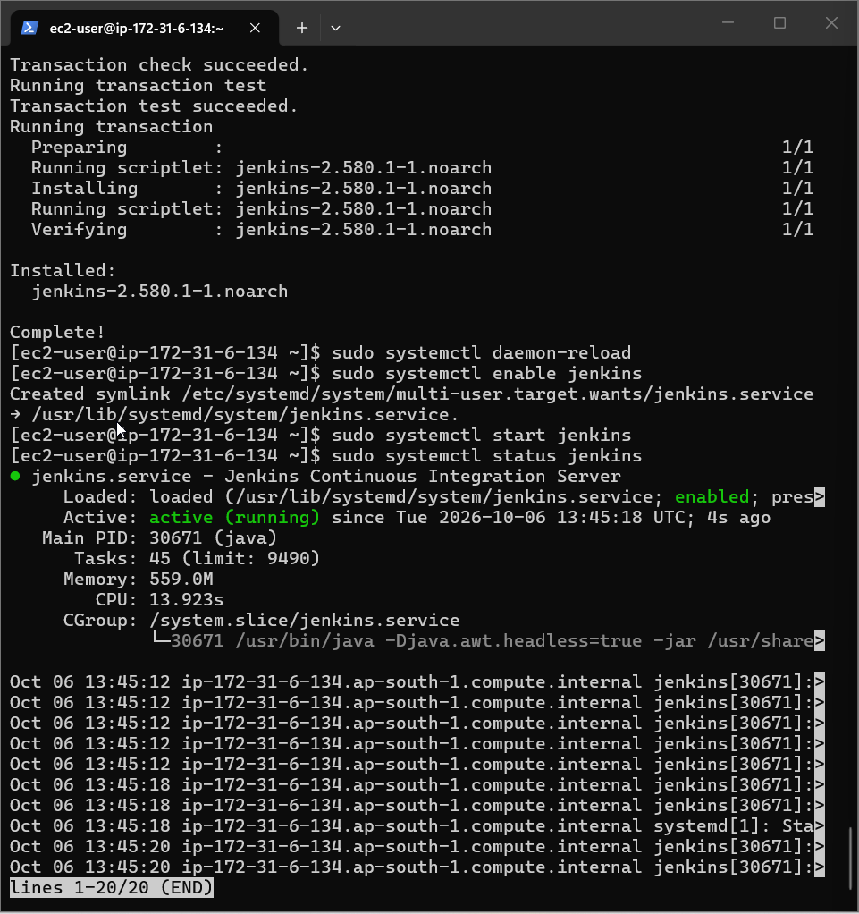

sudo cat /var/lib/jenkins/secrets/initialAdminPassword

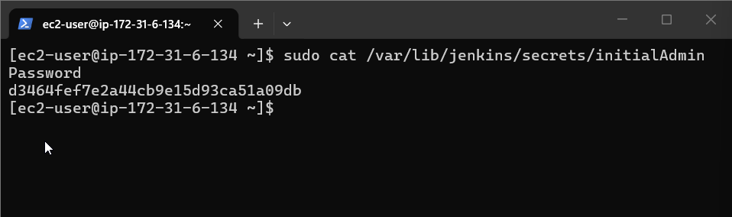

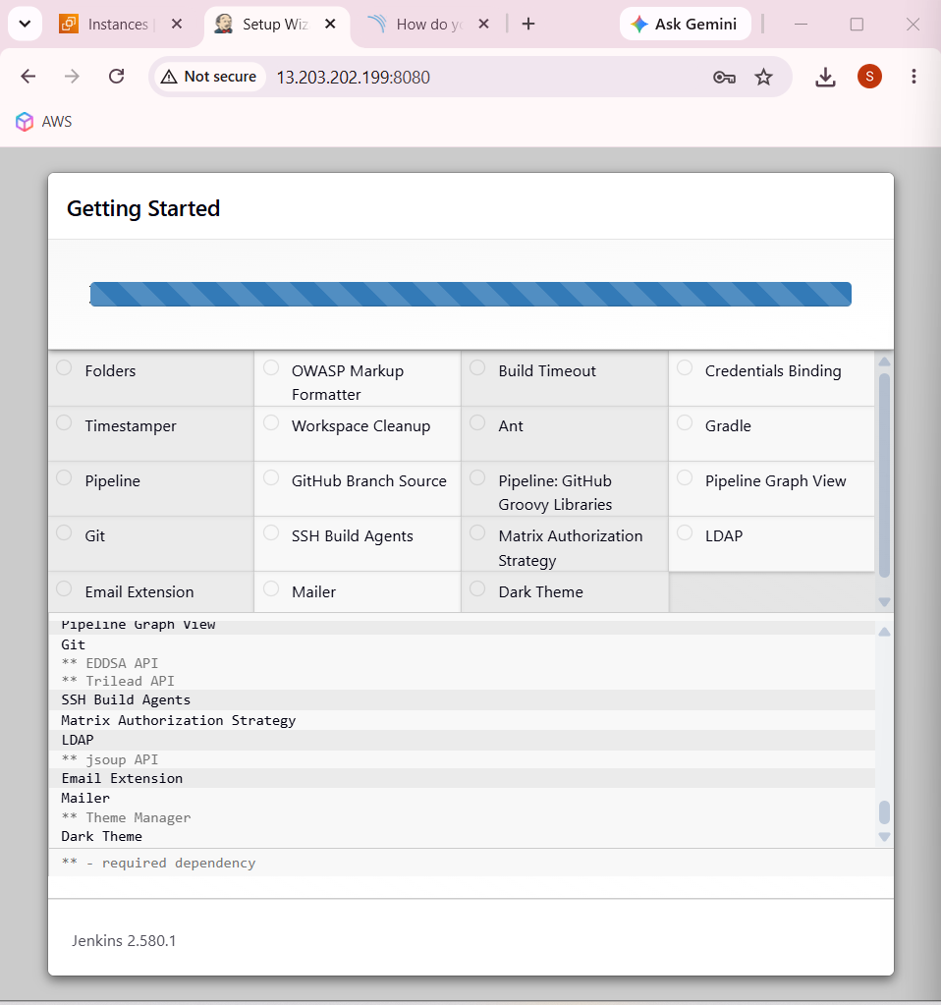

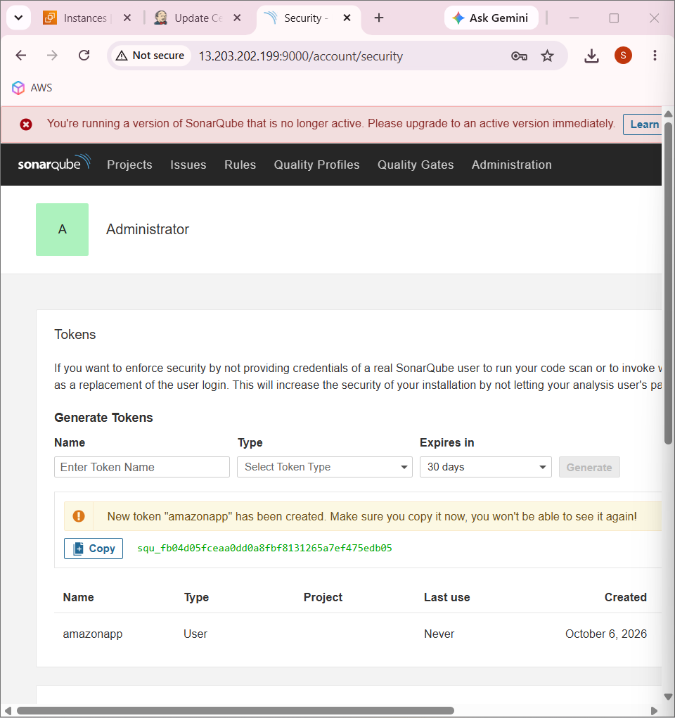

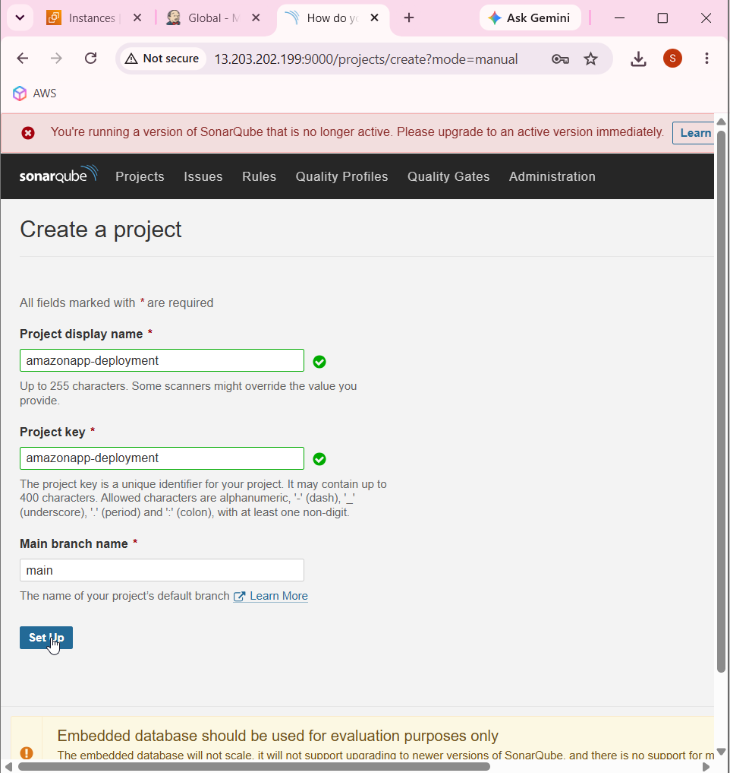

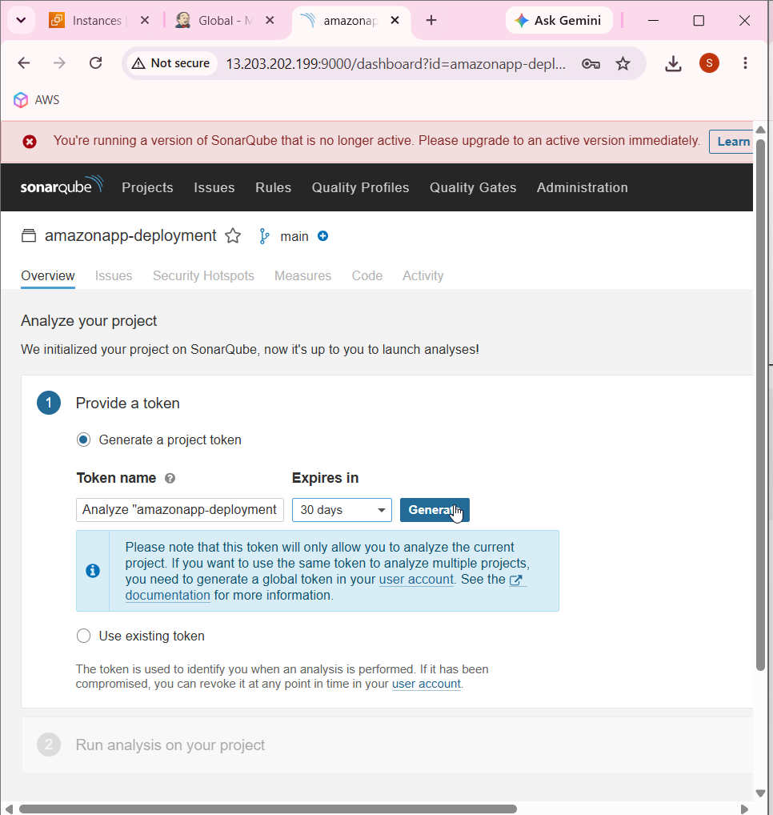

Local

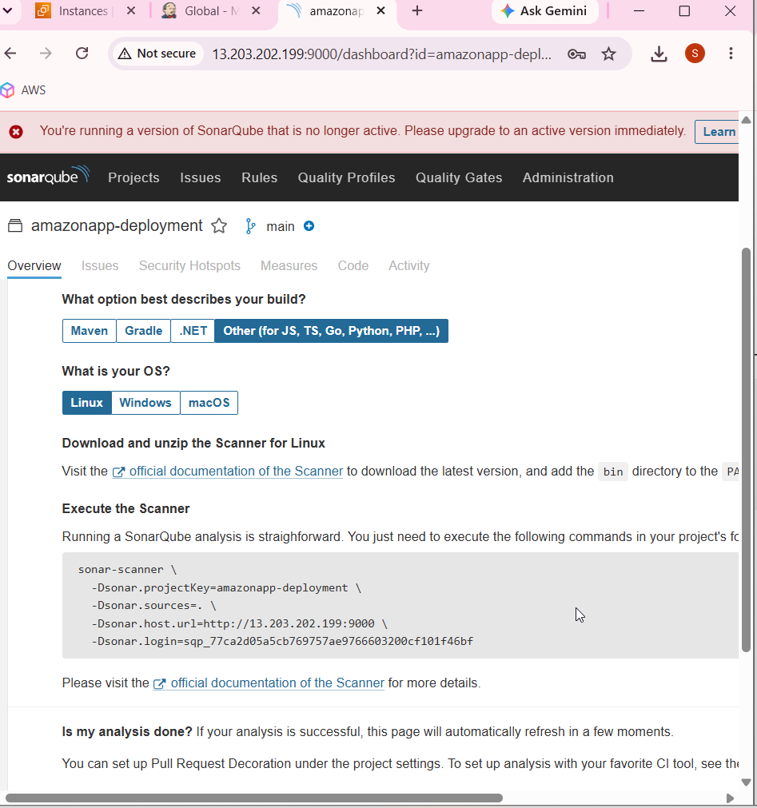

Docker

docker login -u santhanamarig

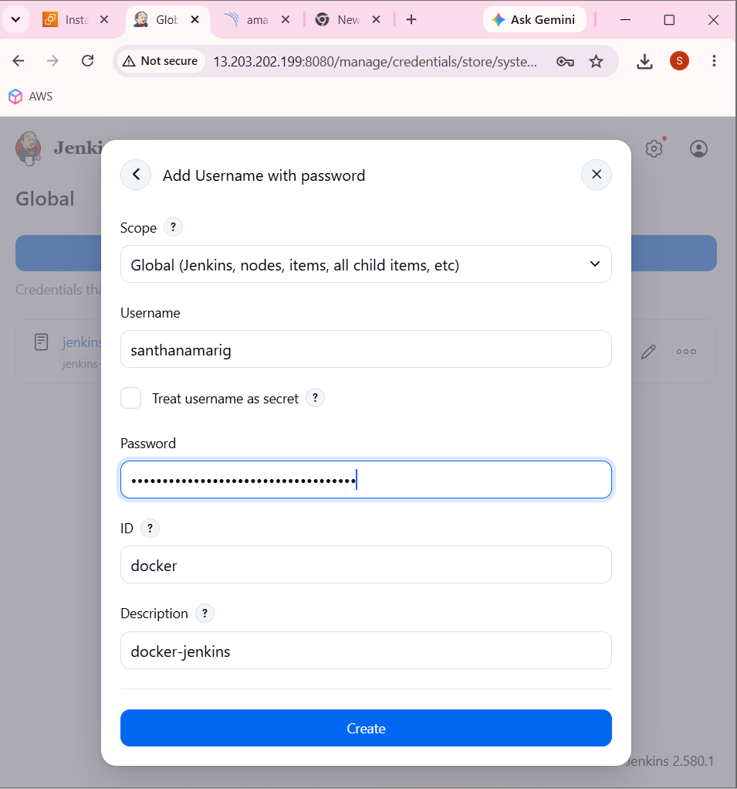

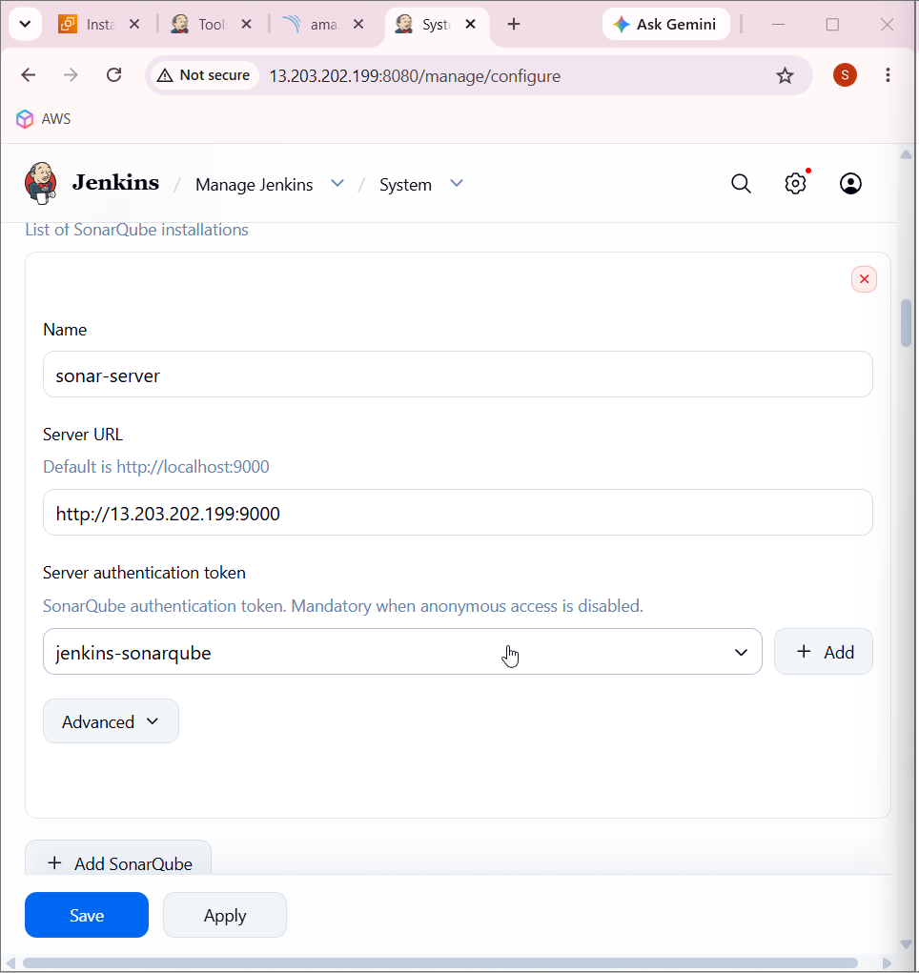

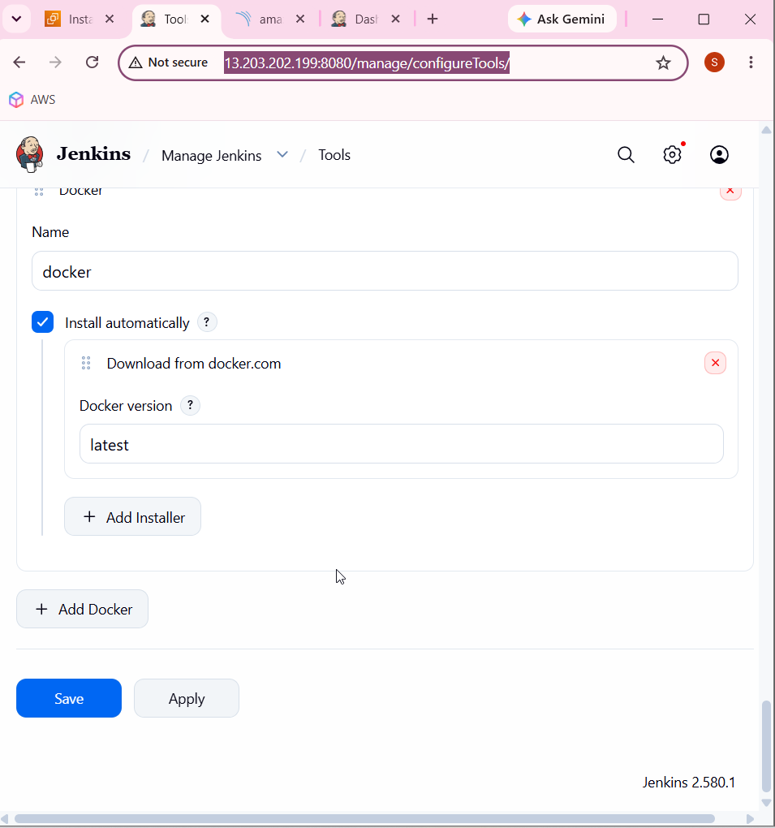

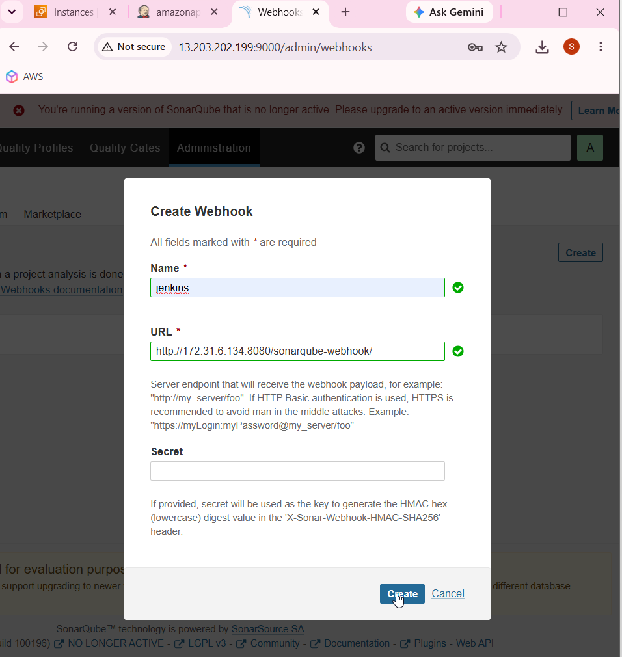

sudo yum install -y libatomic

Install the libatomic package on the system, using administrator privileges, and automatically confirm the installation.

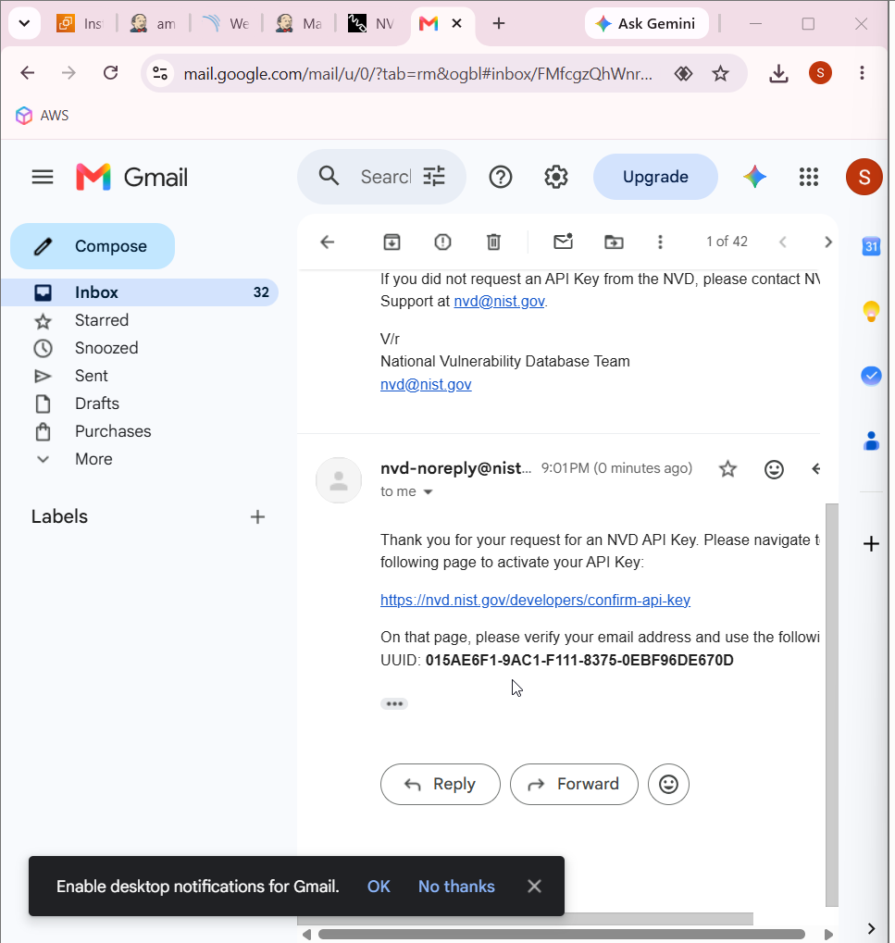

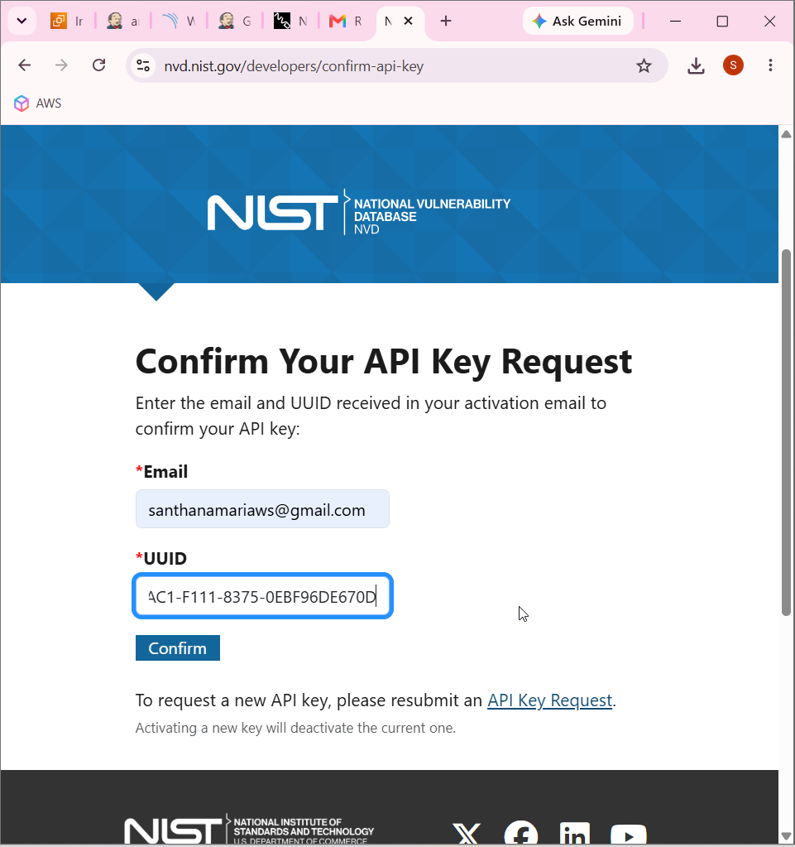

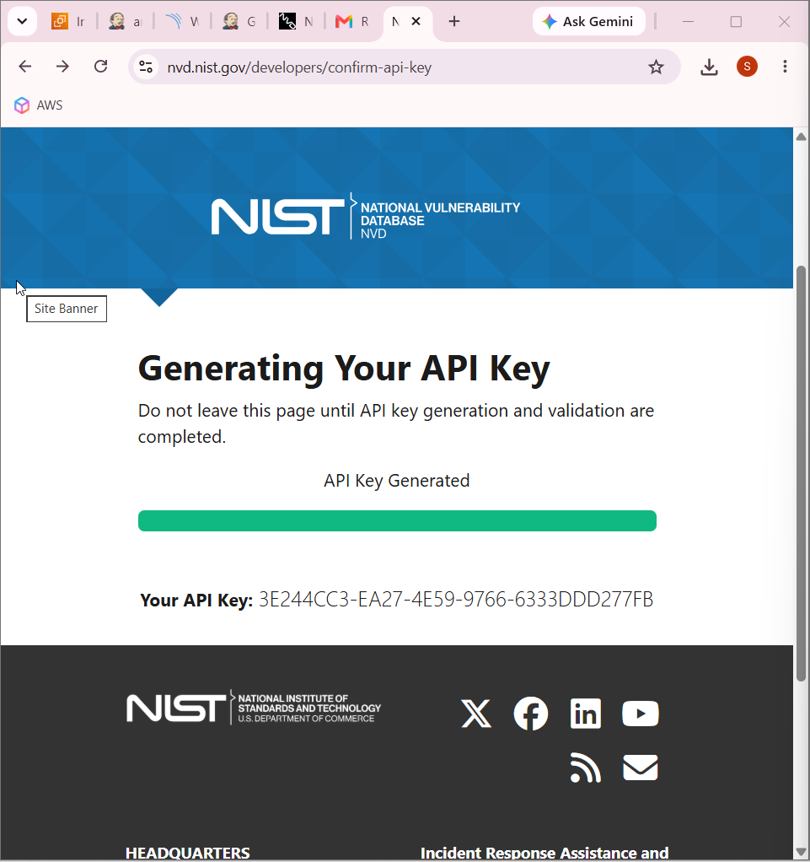

3E244CC3-EA27-4E59-9766-6333DDD277FB

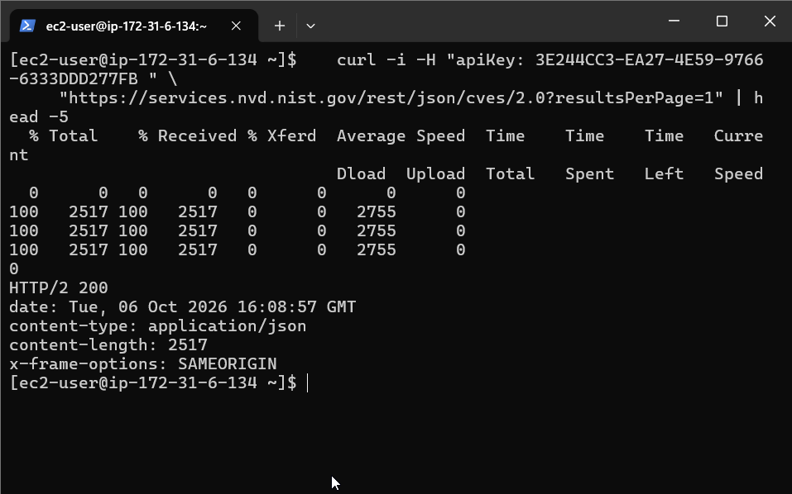
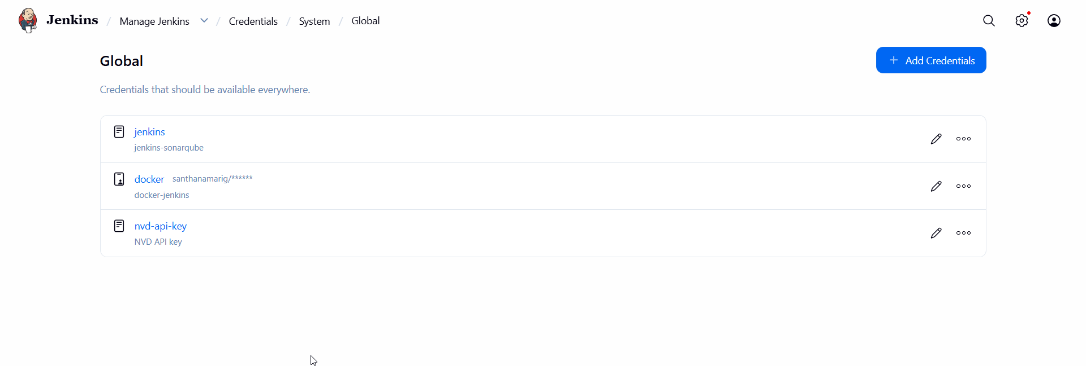

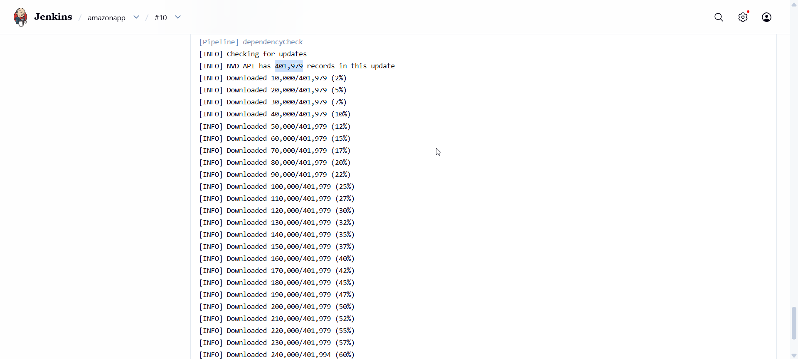

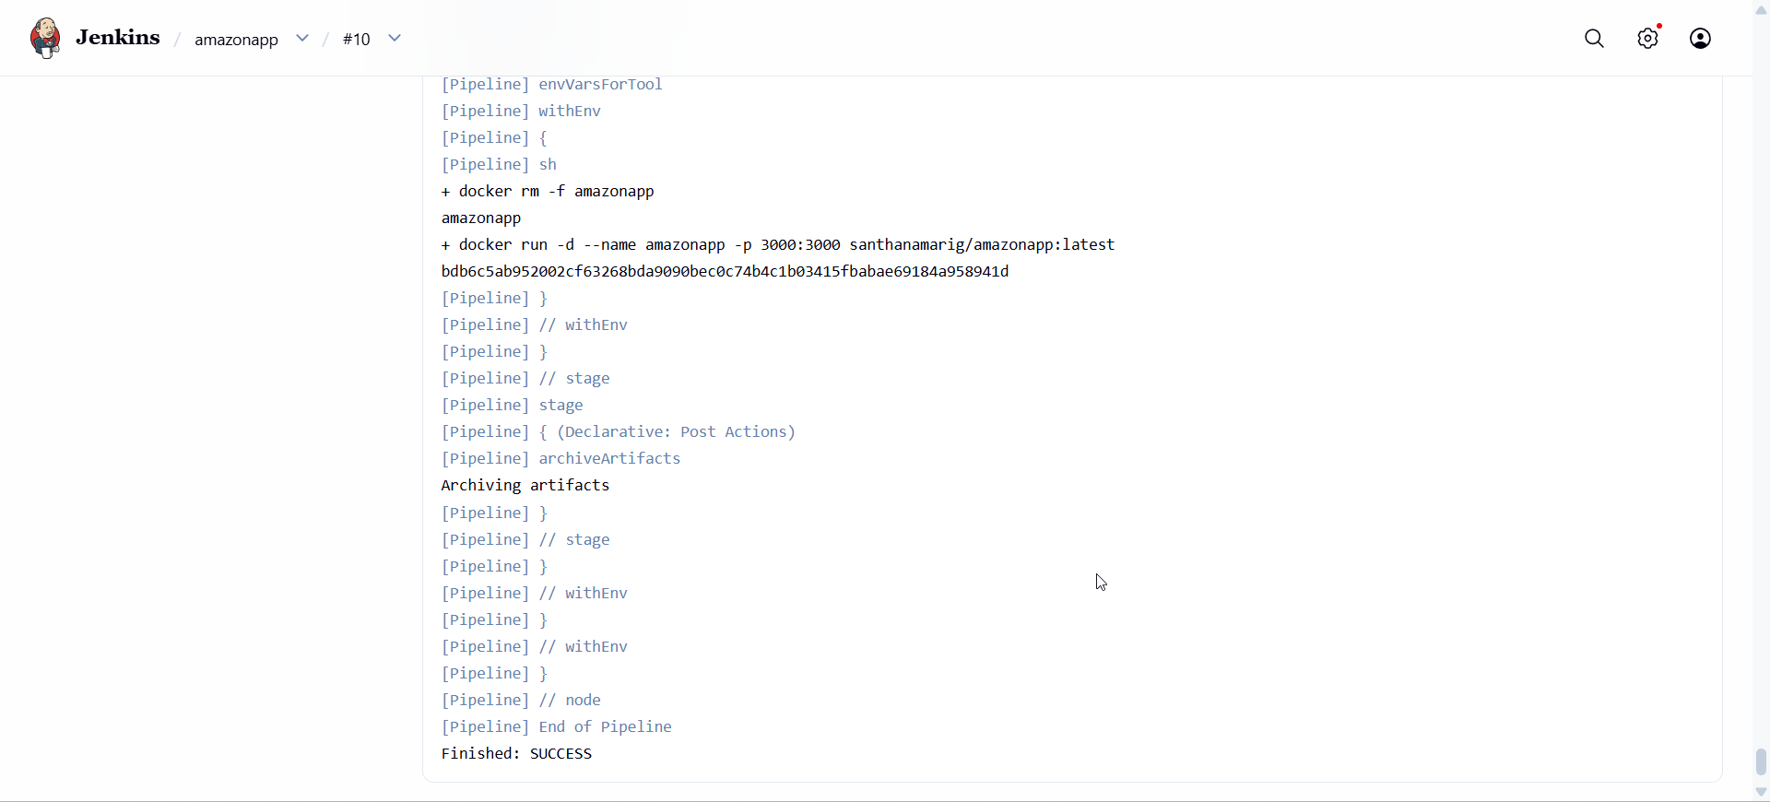

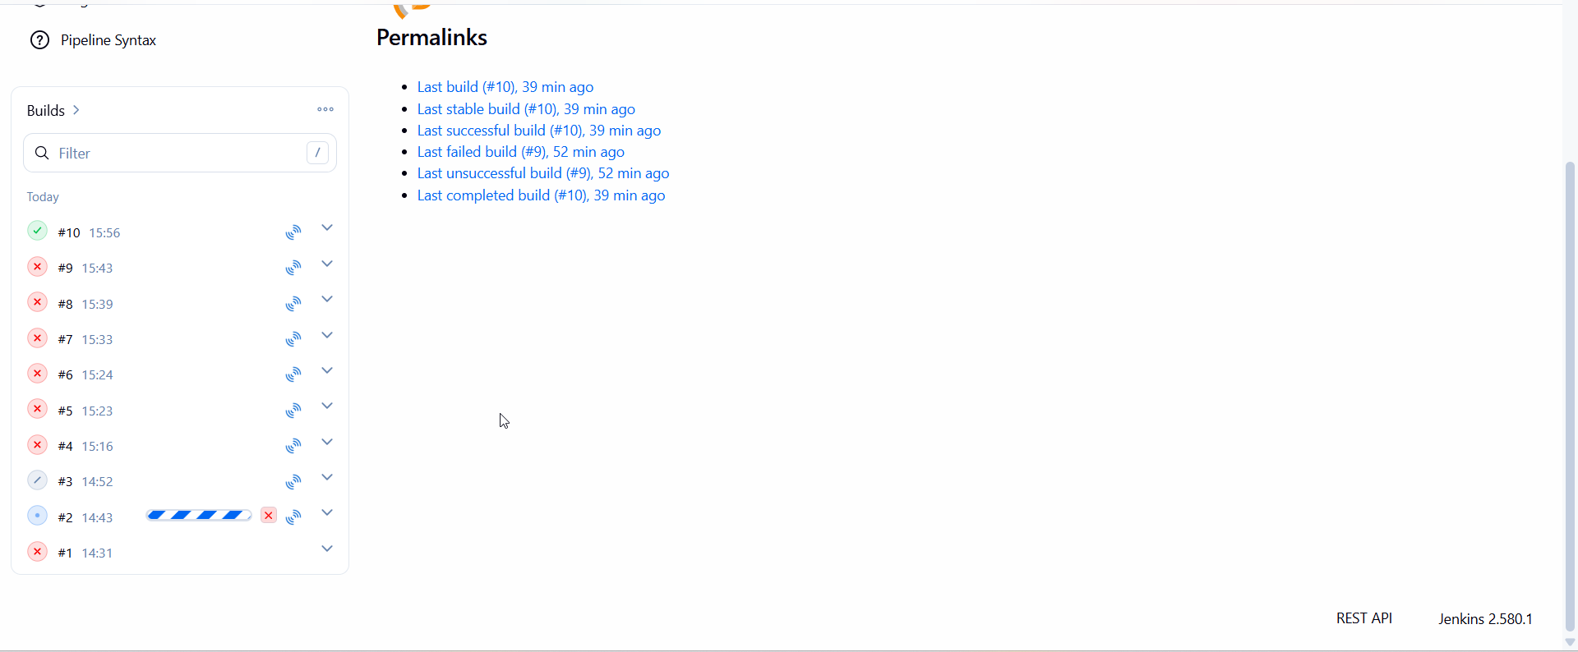

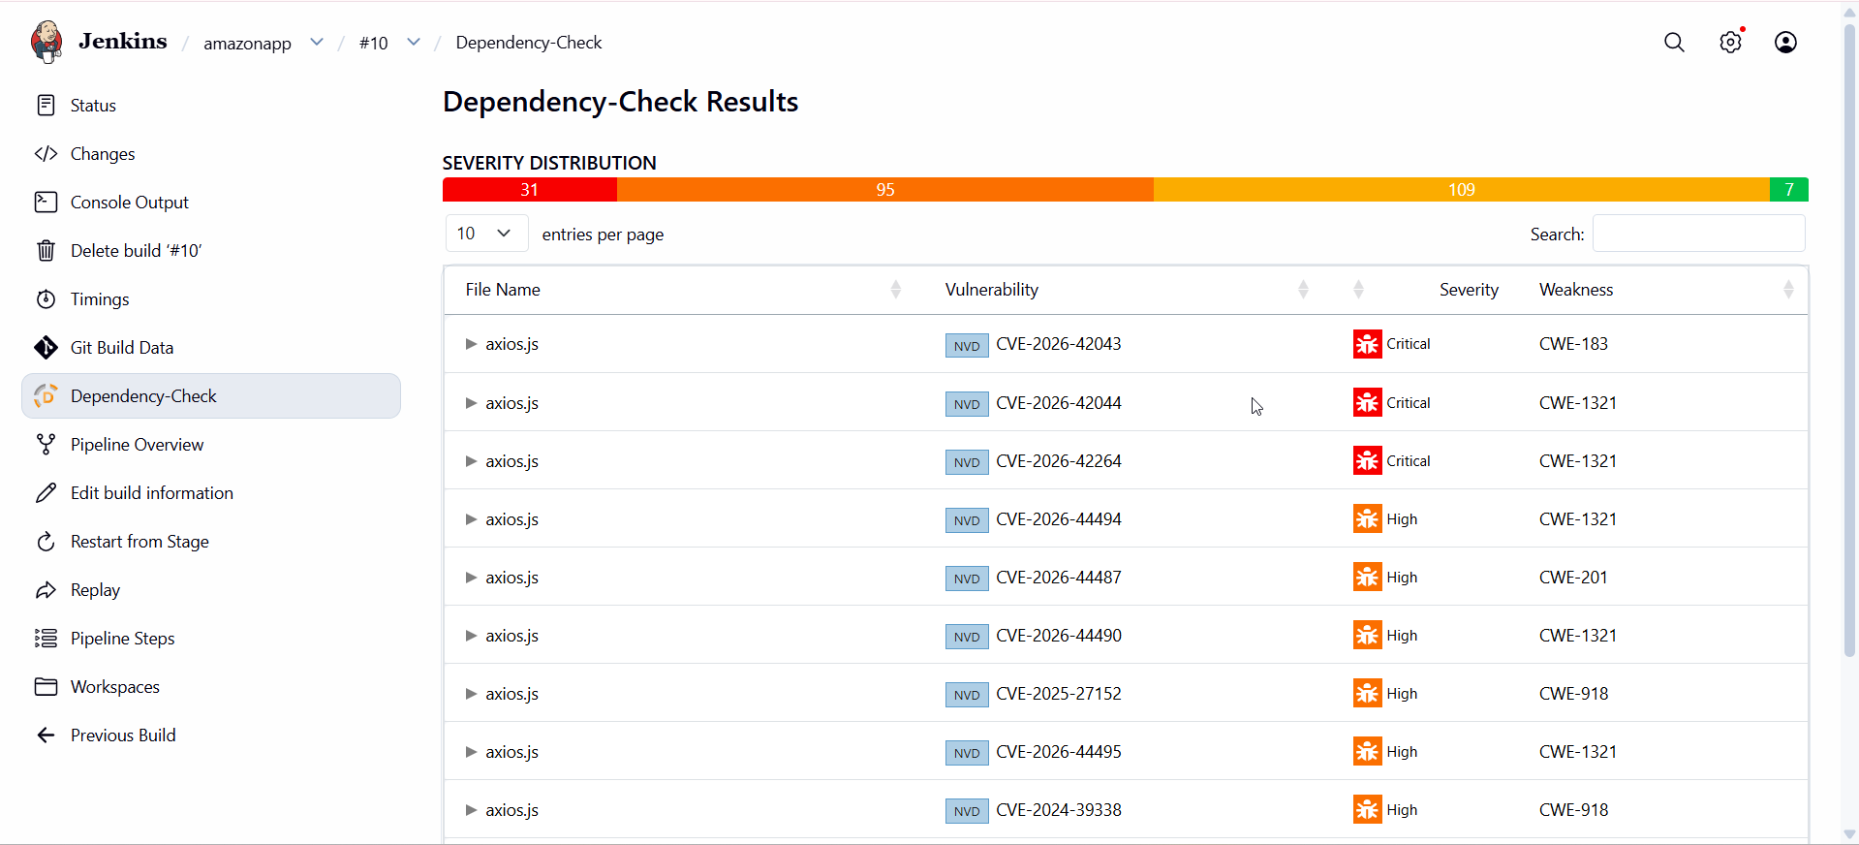

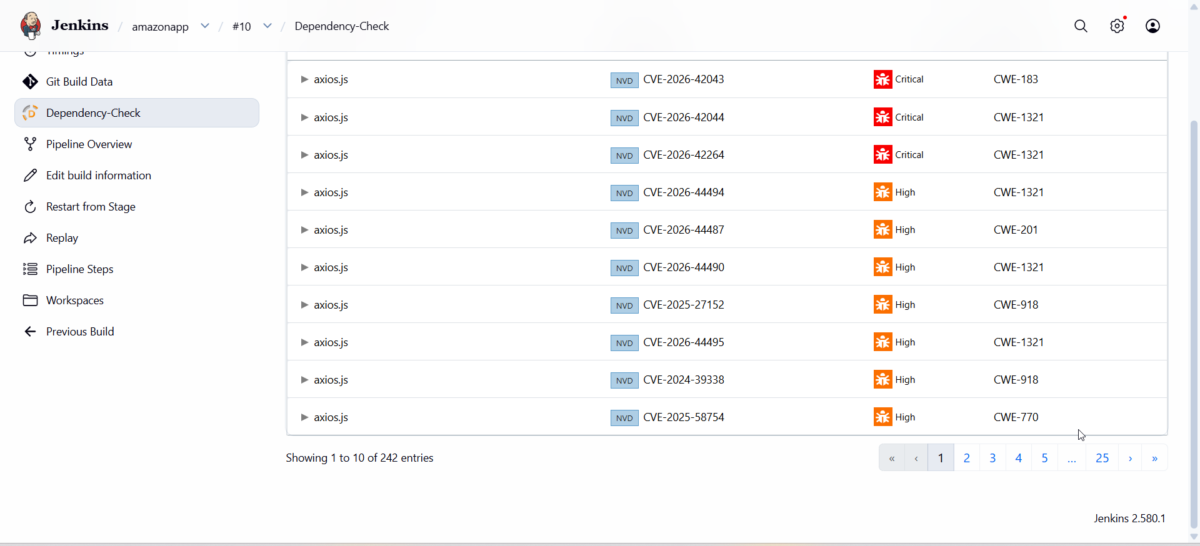

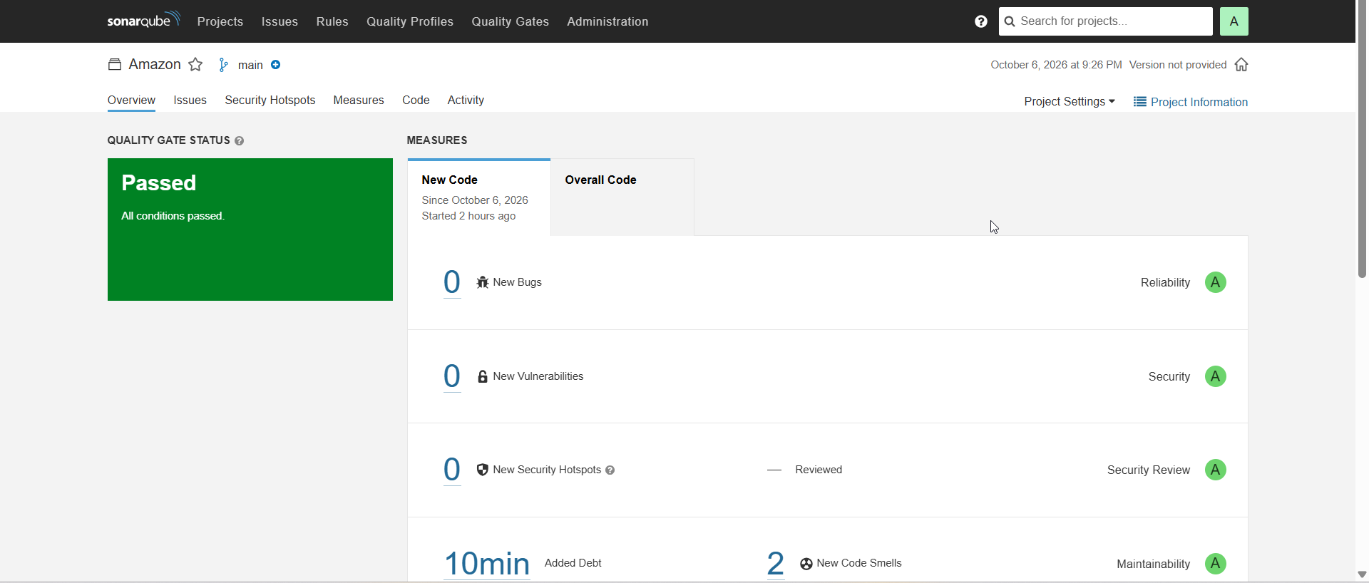

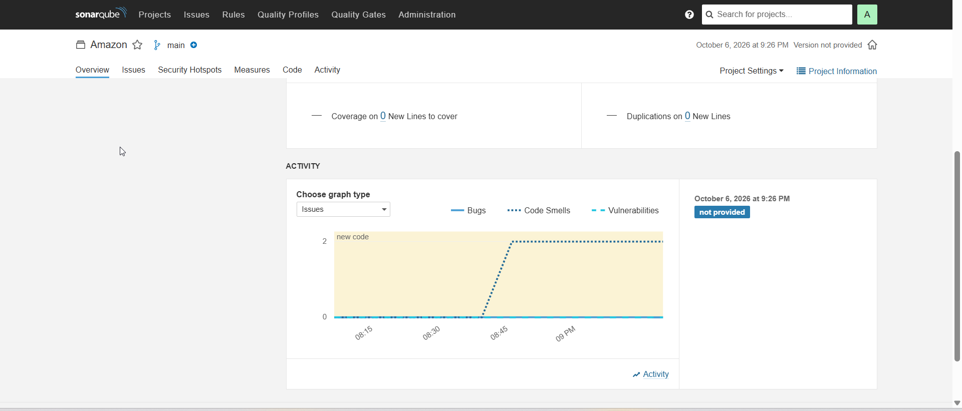

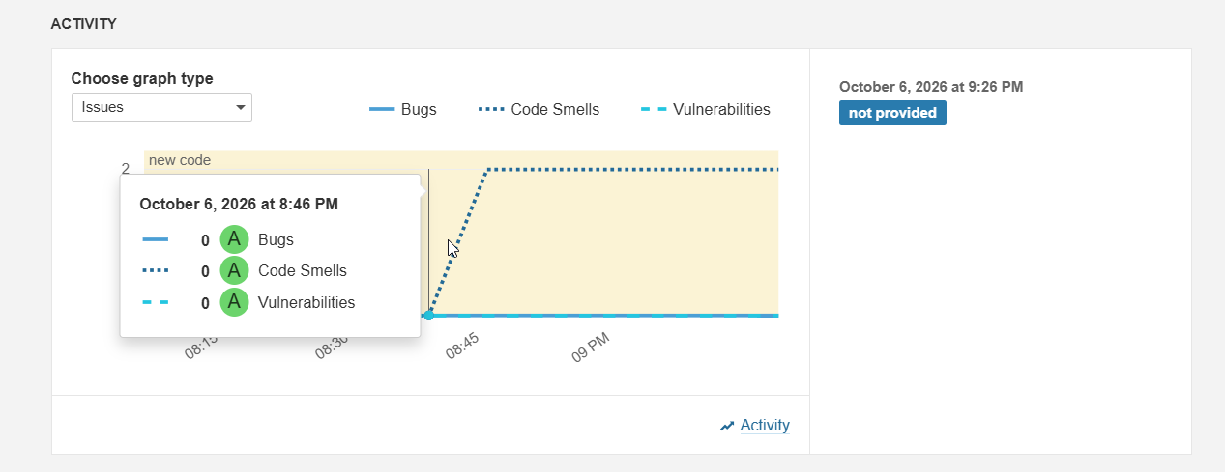

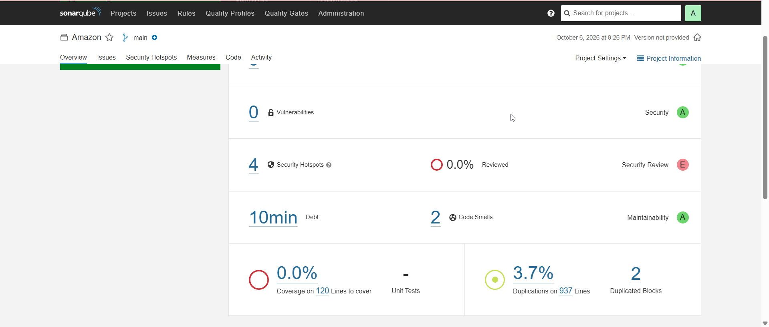

Result

http://13.203.202.199:3000/


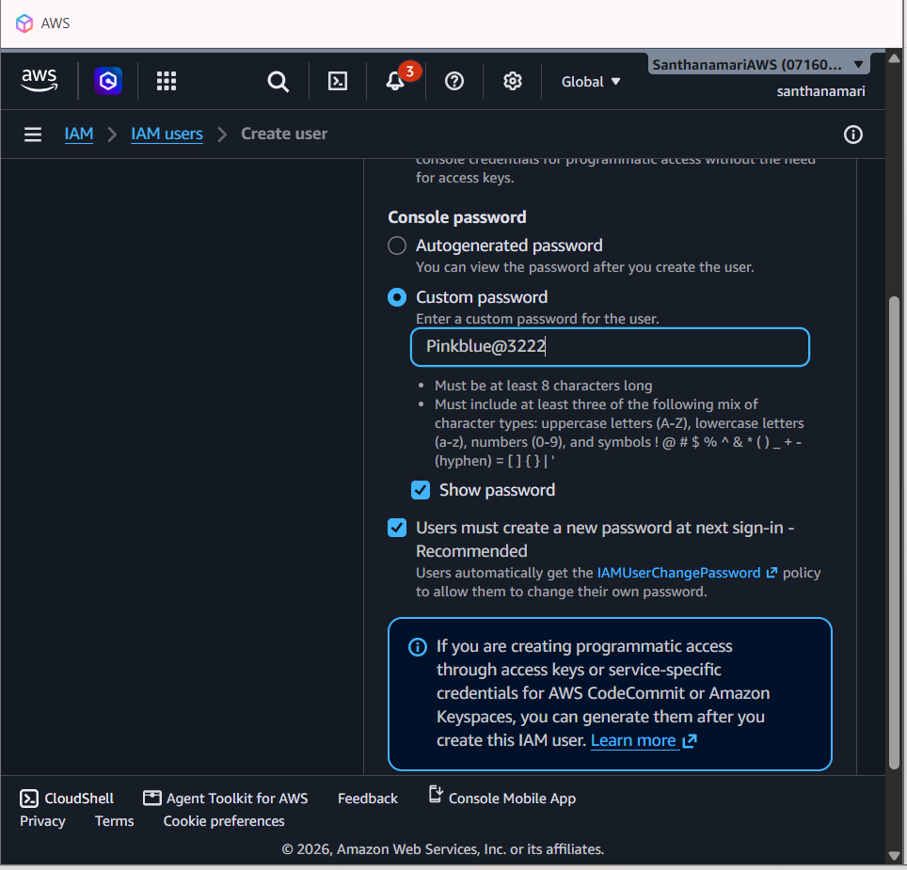






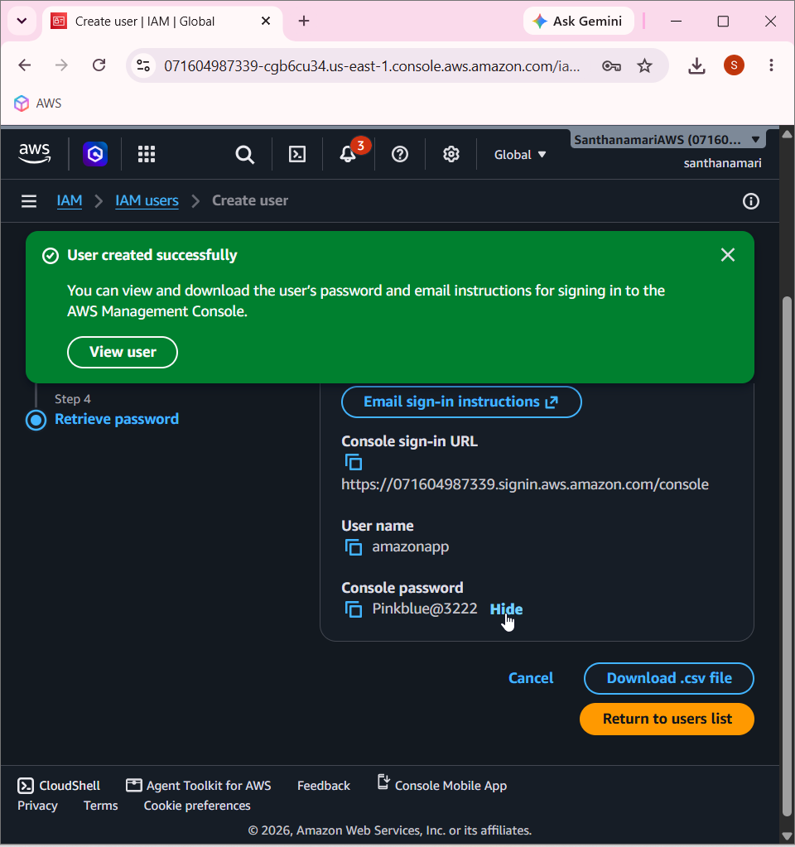

____________________________________________________________________________

Prometheus

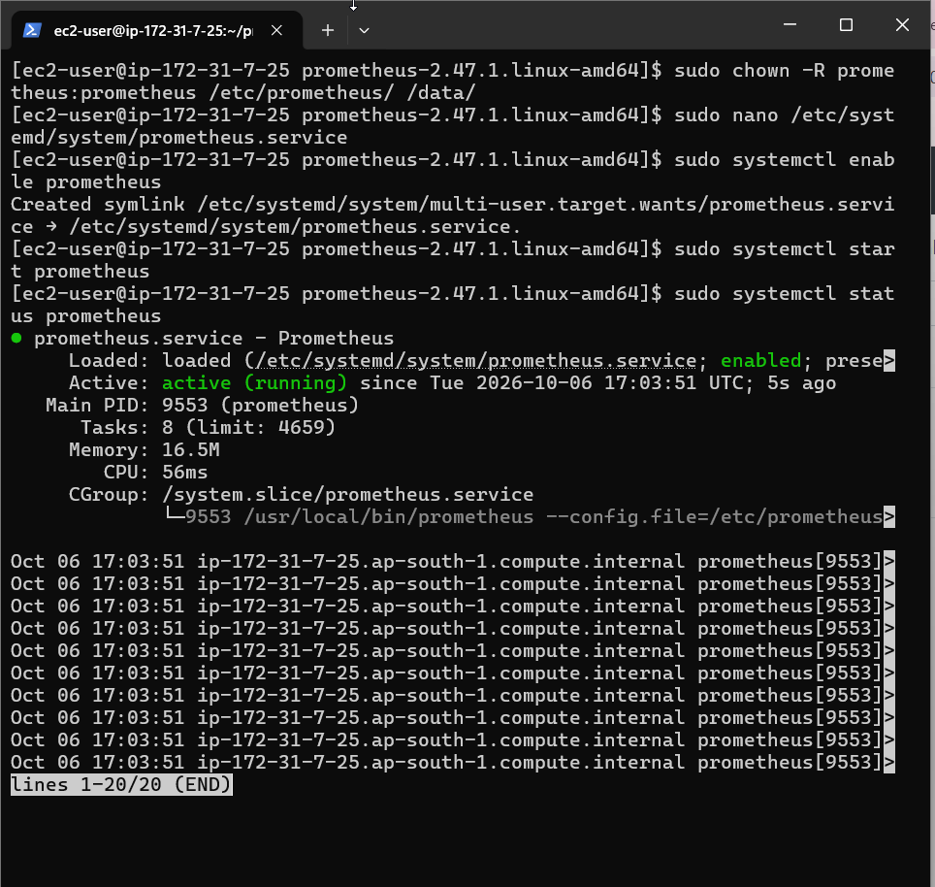

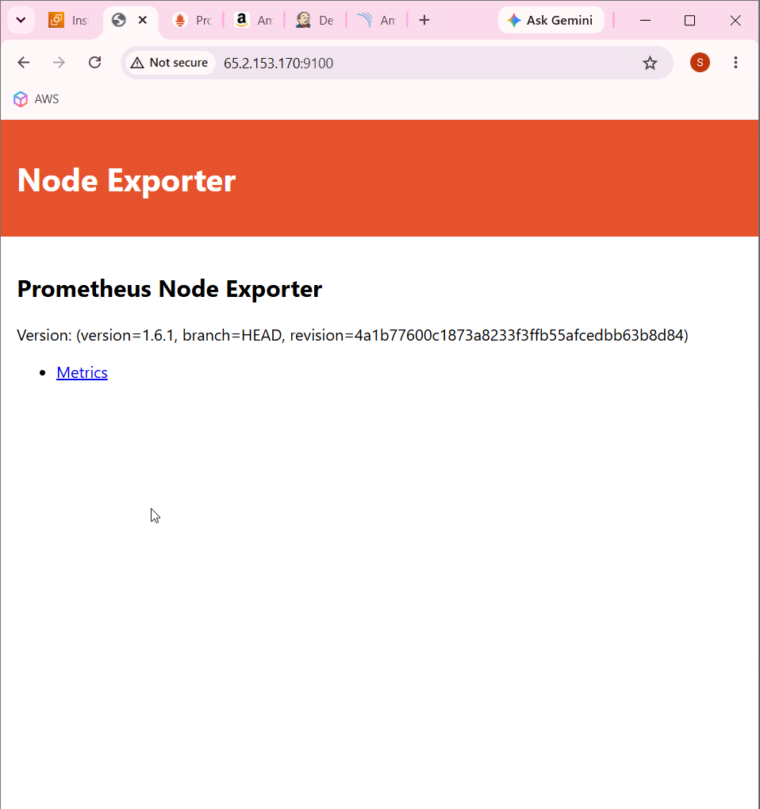

http://65.2.153.170:9100/metrics

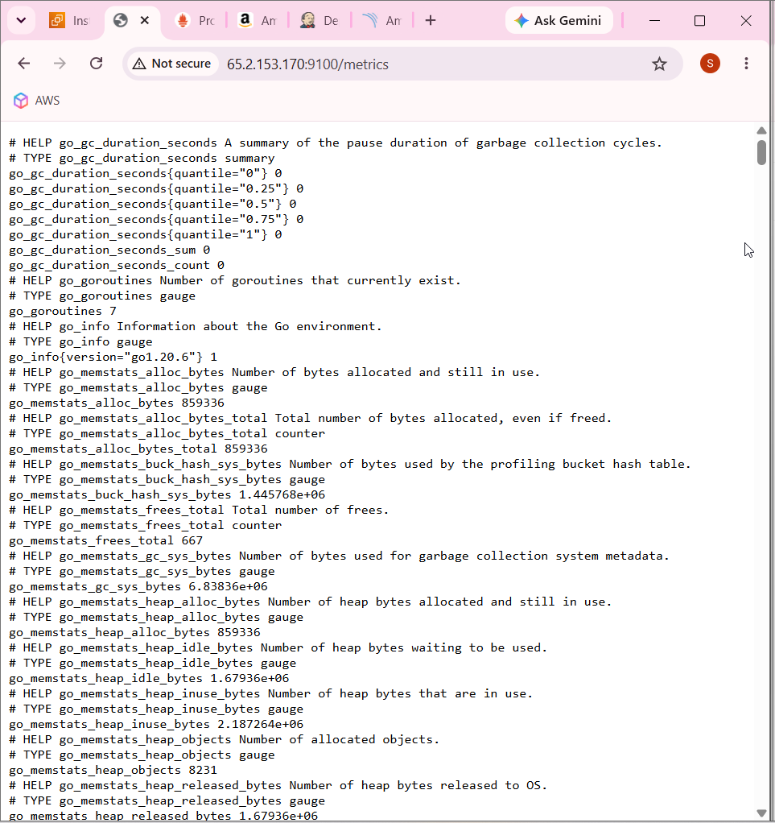

prometheus => localhost:9090
node_exporter => localhost:9100
jenkins => 13.203.202.199:8080

http://65.2.153.170:9090/targets?search=

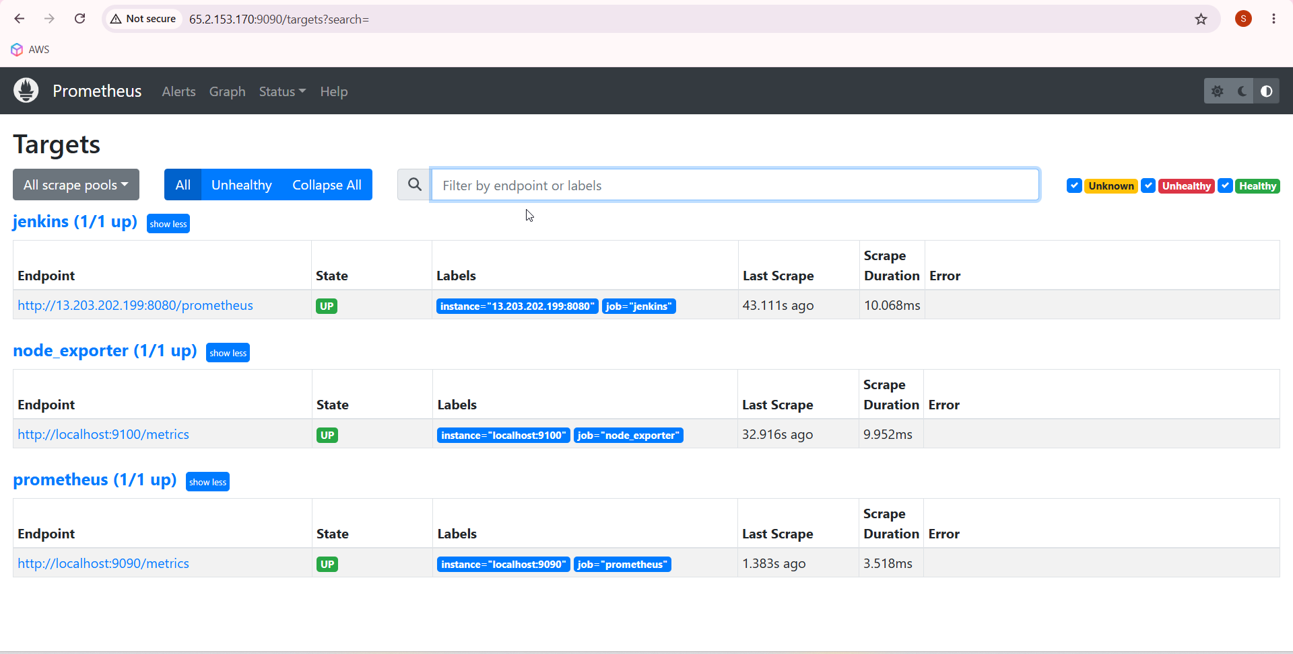

Grafana

sudo yum update -y

sudo tee /etc/yum.repos.d/grafana.repo > /dev/null << 'EOF'
[grafana]
name=grafana
baseurl=https://rpm.grafana.com
repo_gpgcheck=1
enabled=1
gpgcheck=1
gpgkey=https://rpm.grafana.com/gpg.key
sslverify=1
sslcacert=/etc/pki/tls/certs/ca-bundle.crt
EOF

sudo yum install -y grafana
sudo systemctl enable --now grafana-server

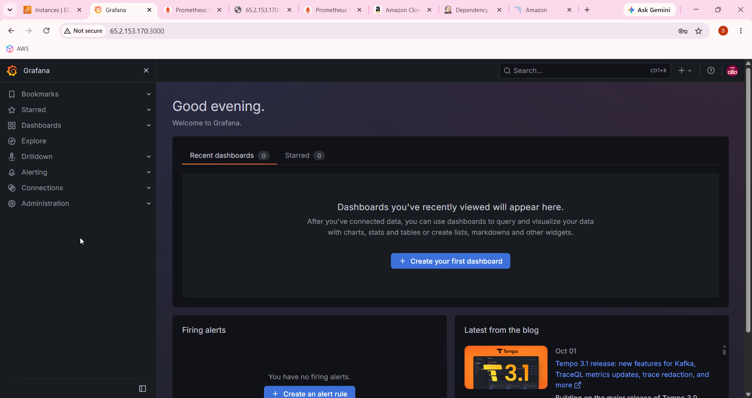

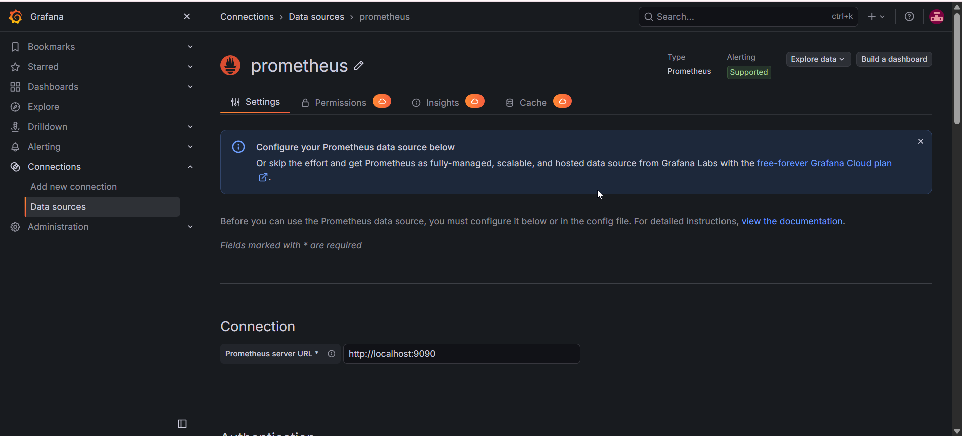

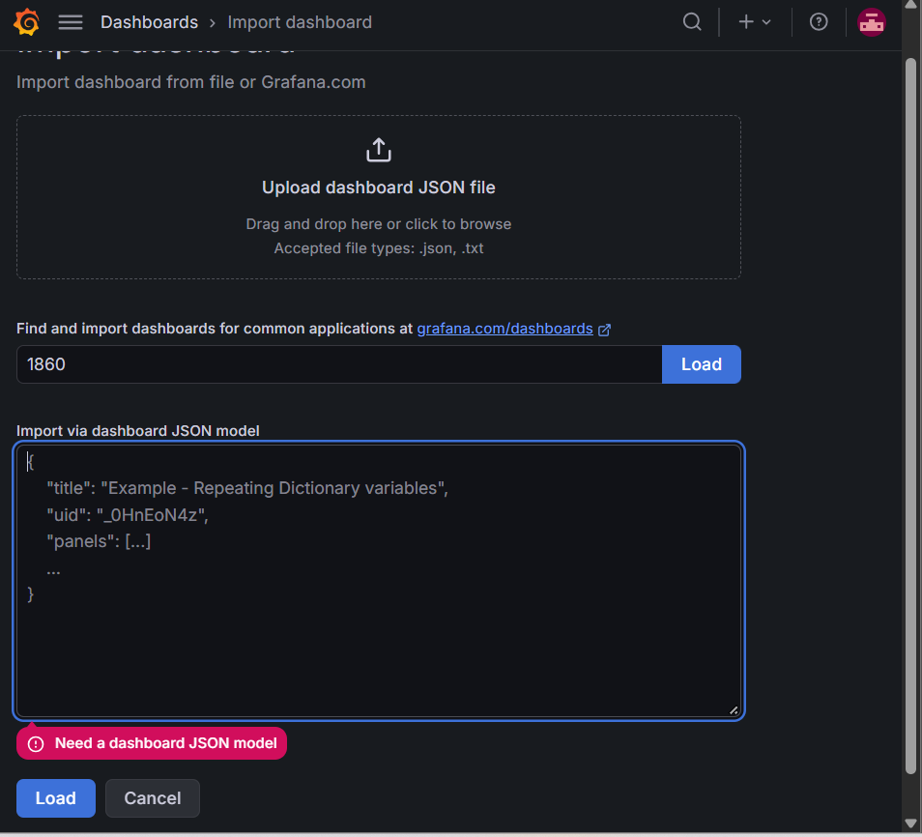

Click load button on 1860

Create prometheus user

sudo useradd --system --no-create-home --shell /bin/false prometheus

wget https://github.com/prometheus/prometheus/releases/download/v2.47.1/prometheus-2.47.1.linux-amd64.tar.gz

tar -xvf prometheus-2.47.1.linux-amd64.tar.gz

cd prometheus-2.47.1.linux-amd64/
sudo mkdir -p /data /etc/prometheus

sudo mv prometheus promtool /usr/local/bin/
sudo mv consoles/ console_libraries/ /etc/prometheus/
sudo mv prometheus.yml /etc/prometheus/prometheus.yml

sudo chown -R prometheus:prometheus /etc/prometheus/ /data/

Create prometheus service

sudo nano /etc/systemd/system/prometheus.service

[Unit]
Description=Prometheus
Wants=network-online.target
After=network-online.target

StartLimitIntervalSec=500
StartLimitBurst=5

[Service]
User=prometheus
Group=prometheus
Type=simple
Restart=on-failure
RestartSec=5s

ExecStart=/usr/local/bin/prometheus \
--config.file=/etc/prometheus/prometheus.yml \
--storage.tsdb.path=/data \
--web.console.templates=/etc/prometheus/consoles \
--web.console.libraries=/etc/prometheus/console_libraries \
--web.listen-address=0.0.0.0:9090 \
--web.enable-lifecycle

[Install]
WantedBy=multi-user.target

sudo systemctl enable prometheus
sudo systemctl start prometheus
sudo systemctl status prometheus

Install node exporter

sudo useradd --system --no-create-home --shell /bin/false node_exporter

wget https://github.com/prometheus/node_exporter/releases/download/v1.6.1/node_exporter-1.6.1.linux-amd64.tar.gz

tar -xvf node_exporter-1.6.1.linux-amd64.tar.gz

sudo mv node_exporter-1.6.1.linux-amd64/node_exporter /usr/local/bin/

rm -rf node_exporter*

Create node exporter service

sudo nano /etc/systemd/system/node_exporter.service

[Unit]
Description=Node Exporter
After=network.target

[Service]
User=node_exporter
Group=node_exporter
Type=simple
ExecStart=/usr/local/bin/node_exporter

[Install]
WantedBy=default.target

sudo chown node_exporter:node_exporter /usr/local/bin/node_exporter

sudo systemctl daemon-reload
sudo systemctl start node_exporter
sudo systemctl enable node_exporter
sudo systemctl status node_exporter

sudo useradd -m -s /bin/bash node_exporter

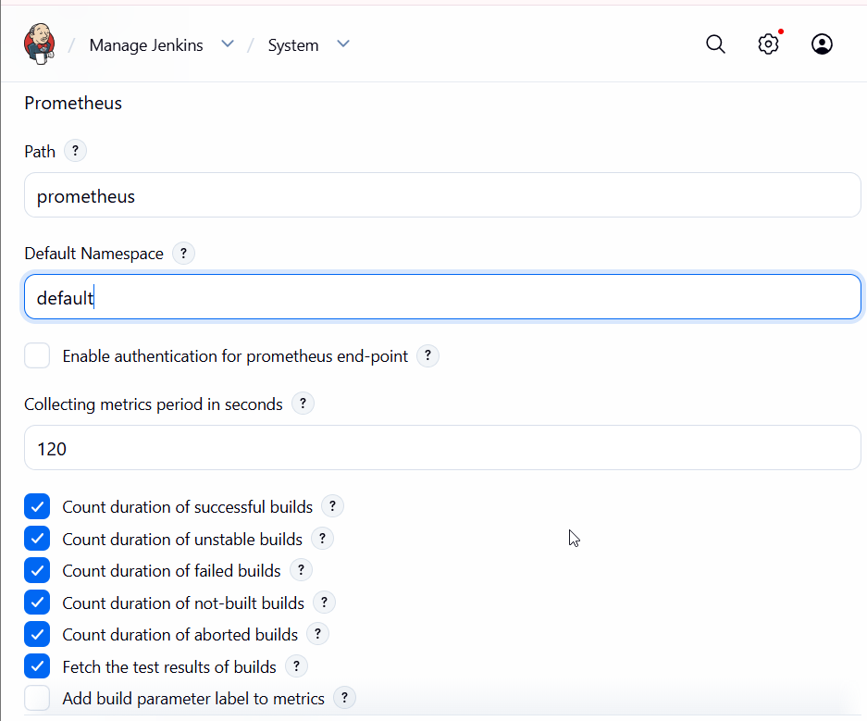

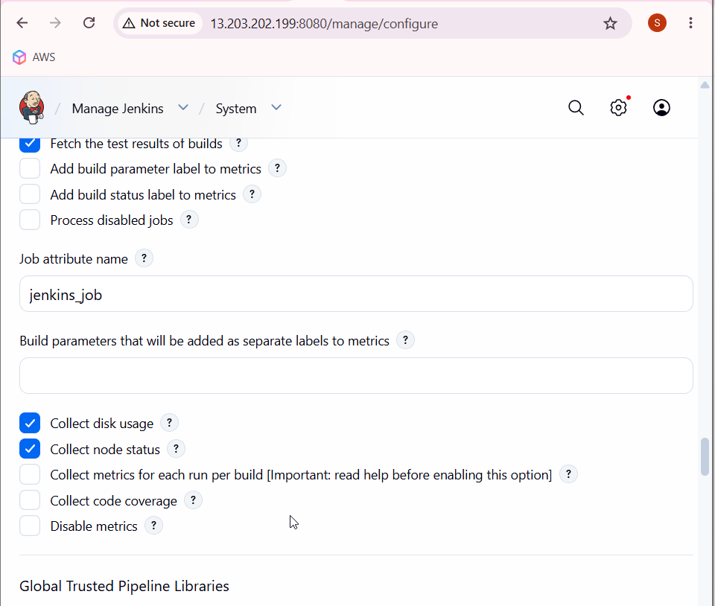

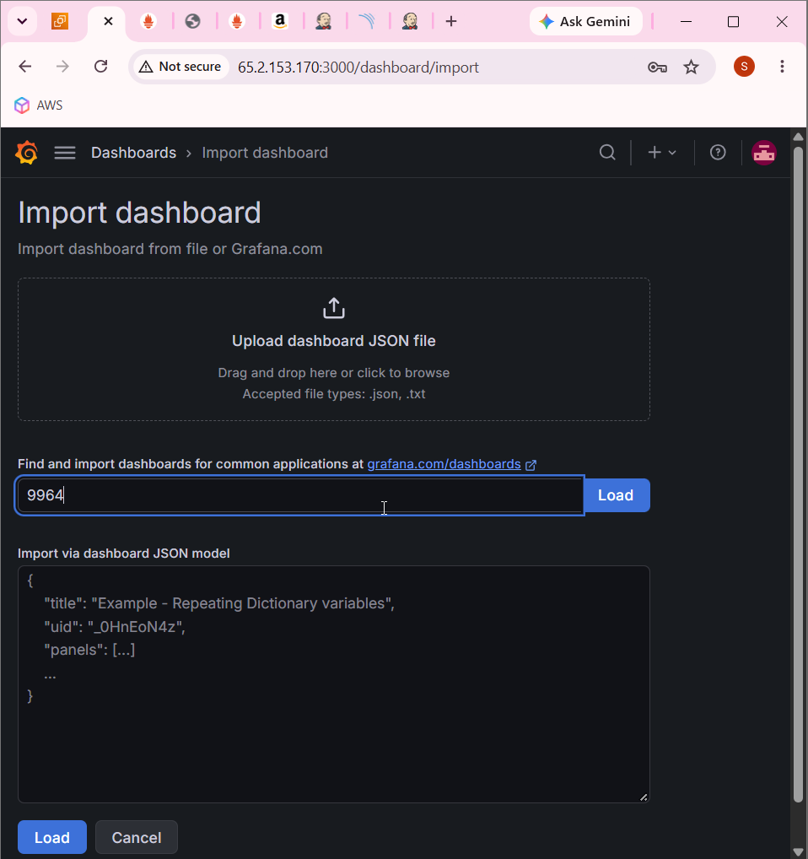

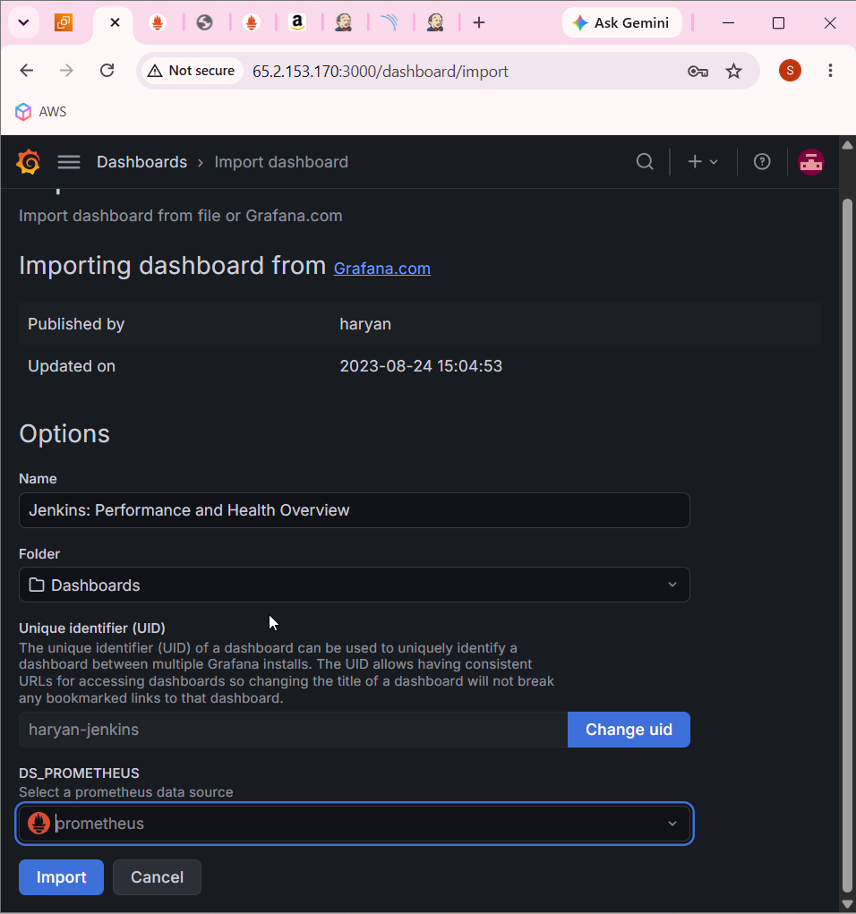

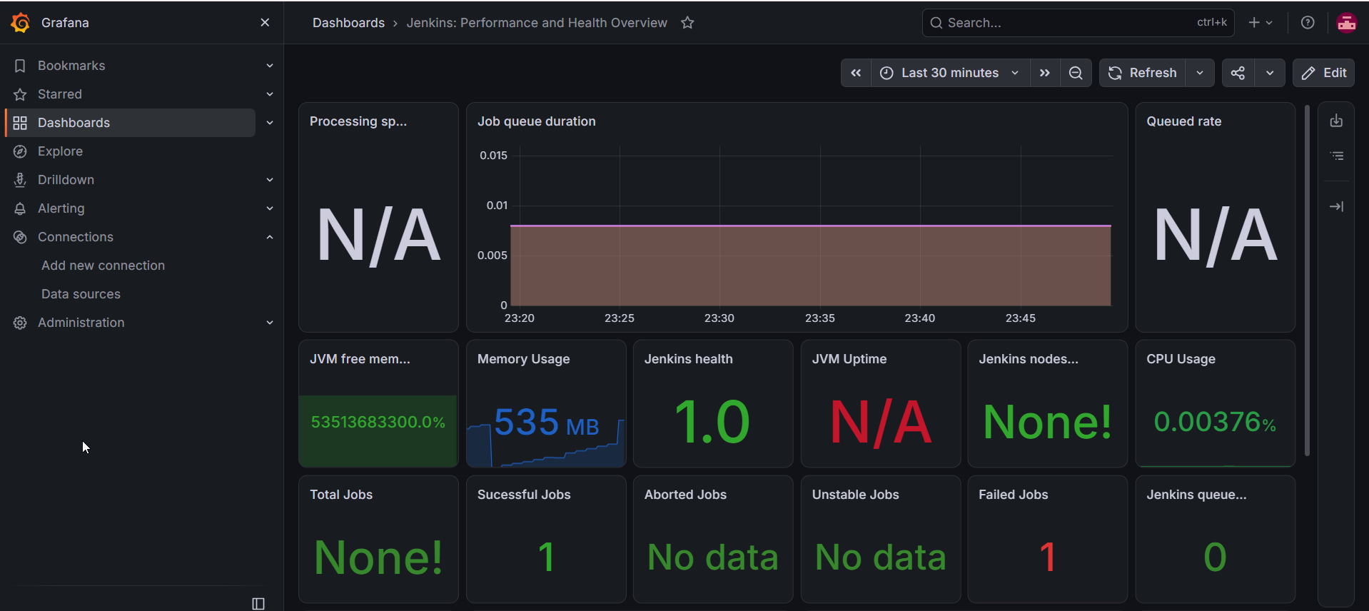

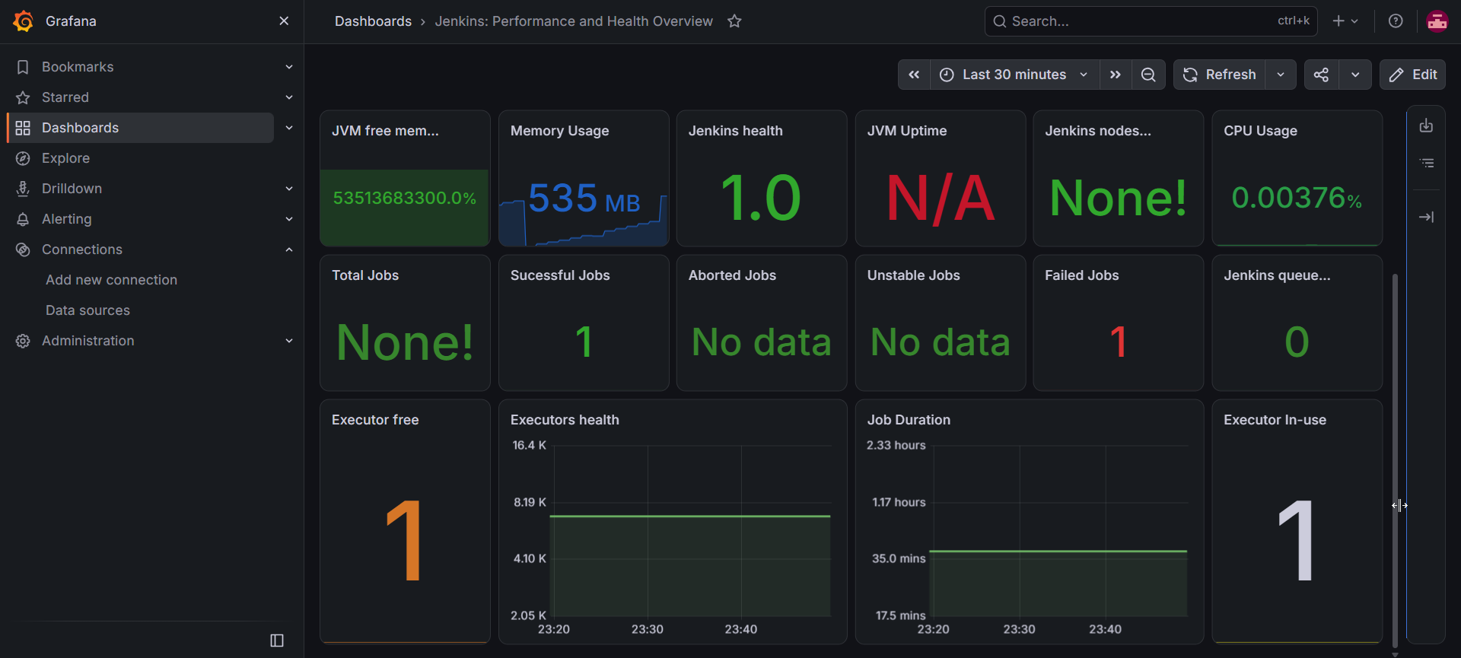

http://65.2.153.170:3000/d/haryan-jenkins/jenkins3a-performance-and-health-overview



___________________________________________________________________________

